Information Pack
Artists Make Space 2026-27
Creative workspaces for artists
provided by Richmond Arts Service
_________________________________________________________________________
Contents:
- Summary & eligibility
- Artist role
- Arts Service role
- Frequently Asked Questions (FAQs)
- Appendix A - Spaces available
_________________________________________________________________________
Summary:
Richmond Arts Service invites arts organisations, artist collectives’ and individual artists living, working or studying in Richmond upon Thames to apply to our Artists Make Space Programme.
Artists who do not currently live or work in Richmond upon Thames may apply if they are able to demonstrate that they will bring something innovative and exciting to the borough during their proposed residency, however priority is given to those who live, work or study in the Borough.
The selected artists, artist organisations or artist collectives will be supported with a space free of charge to practice their art, experiment with new creative techniques, hold meetings, etc.
This programme is aimed at artists who do not currently have studio space for financial reasons, who do not have the appropriate type of space for a specific project or experimentation in expanding their practice, or who can demonstrate that the programme will help to grow their practice in a way that would not otherwise be possible.
Spaces on offer are located at:
- Orleans House Gallery, Twickenham
- The Old Town Hall, Richmond
- OSO Arts Centre, Barnes
We welcome applications from a range of practitioners looking to utilise our spaces across artforms including Music, Theatre, Dance, Visual Arts, Literature, and Combined Arts.
To be eligible for this programme, artists must have an existing practice and be aged 18 or older. We are keen to work with artists from a variety of backgrounds with different skills, stories, and experiences. We actively seek applications from our diverse communities including Global Majority, Deaf, disabled, neurodivergent, and LGBTQ+, to represent diverse lived experiences in our projects.

To apply, send a completed application form to artsinfo@richmondandwandsworth.gov.uk with the subject line Artists Make Space 2026-2027 and your name. Applications must be received by Sunday 5 July 2026 at 11.59pm.
_________________________________________________________________________
Artist role:
We want to work with artists who are committed to developing their practice, are socially engaged, and reflect London’s diversity in the art and programmes they produce and the communities they engage.
The Arts Service encourages the artist(s) to:
- Help animate the space through their artistic practice.
- Commit to the programme and maximise the use of the space and opportunity throughout your period of occupation.
- Work with the Arts Service to share their involvement with the programme with the public e.g. through blog posts, open studio sessions, etc
- Participate in evaluation
- Engage with one or more of our core values, which are:
  - Collaborative - we work with people in innovative and inspiring ways, we invite artists, communities and individuals to create the public programme with us and help develop the arts service.
  - Socially engaged - we respond to the needs and wishes of local people, widen participation in the arts and connect people from different backgrounds, enabling them to have a say over issues that affect them, and promoting opportunity particularly for underrepresented groups.
  - Experimental - through the arts we test new ideas and approaches and share our learning to support the work of the borough. This might involve being playful, adventurous and taking risks.
_________________________________________________________________________
Richmond Arts Service's role:
The Arts Service will
- Provide studio / work / meeting space at no cost for the length of the agreement and will provide access to the space during agreed hours.
- Provide advice and guidance for the artist (i.e., funding or portfolio advice and consultation of up 2 hours).
- Provide an induction and make introductions so the artist can connect with relevant council staff as well as the creative sector locally and regionally.
- Help the artist develop an online method for promoting and sharing their Artists Make Space experience to reach wider audiences.
- Provide one meeting quarterly with an Arts Officer to catch up, reflect on and review how the programme is working for the artist.
_________________________________________________________________________

Frequently Asked Questions (FAQs)
Can I apply for this artist opportunity at the same time as another opportunity you have live?

Yes!

Can I apply if I live outside the borough?

This opportunity is primarily for arts organisations, artist collectives’ and individual artists living, working or studying in Richmond upon Thames. Artists who do not currently live, work or study in Richmond upon Thames may apply if they are able to demonstrate that they will bring something innovative and exciting to the borough during their proposed residency, however priority is given to Borough-based artists.

Can I apply if I live abroad?

No, this opportunity provides a working space only. It does not include living space or payment and therefore it is not suitable for artists who do not live within a commutable distance to the working spaces.

Can I apply to present an exhibition?

No, this opportunity is designed to give artists the freedom to experiment or work on a specific project without worrying about the outcome. This programme is not an exhibition opportunity. Please check the Artist Opportunities page on the Orleans House Gallery website for open call exhibitions.

Can I apply to host public workshops, lessons or coaching?

No, this programme is intended to develop the practice of the applicant. This is not an open call to facilitate workshops or hold paid-for lessons/coaching.

How can I involve the public if I am chosen?

Public participations can be discussed at the interview stage or during the programme. Past Artists Make Space artists involved the public through open studios, film screenings intended to form part of the artist’s research and round table discussions. This programme is not designed to host public workshops or exhibitions.

Can I visit the spaces?

We’re unable to accommodate site visits with a member of the team at this stage of the application. However, applicants are able to visit the venues during opening hours and images of the specific spaces are available in this pack.

What file-format should media be sent in?

Please send your completed application document and Curriculum Vitae as a PDF or Word document. If you are sending images, these can be sent as PDF documents, PNG images and JPEG/JPG images.

Here’s a list of additional file-formats we are able to receive: Windows Media formats (.asf, .wma, .wmv, .wm) Audio Visual Interleave (.avi) Moving Pictures Experts Group (.mpg, .mpeg, .m1v, .mp2, .mp3, .mpa, .mpe, .m3u) Musical Instrument Digital Interface (.mid, .midi, .rmi) Audio Interchange File Format (.aif, .aifc, .aiff) Audio for Windows (.wav) QuickTime Movie file (.mov) MP4 Audio file (.m4a) MP4 Video file (.mp4, .m4v, .mp4v, .3g2, .3gp2, .3gp, .3gpp)

Kindly note that we are unable to access applications sent as Pages documents, WeTransfer file transfers, Dropbox folders/links or Google Drive links.

When do I find out if my proposal has been accepted?

Successful applicants will be notified by end-July 2026.

_________________________________________________________________________

Appendix A – Spaces Available
Artists Make Space 2026-2027
Creative workspaces for artists
from Richmond Arts Service

Important:
We are open to your needs as artists. You may propose to use a space for a different amount of time or frequency if it is best for your practice.
_________________________________________________________________________
Spaces available:
- The Old Town Hall, Richmond
  - 11-month placements available between September 2026 - July 2027
- Workshop at Orleans House Gallery
  - 3-week placement in May 2027

- Studio at Orleans House Gallery
  - 11-month placement available between September 2026 - July 2027
- Coach House at Orleans House Gallery
  - 3 to 7-month placement available weekly between September 2026 - July 2027
- Training Room at Orleans House Gallery
  - One-week placement available in early 2027
  - 3-6-month placements available on weekends (excluding a few dates), September 2026 - July 2027
- Grounds of Orleans House Gallery (outdoors only)
  - 1 to 6-month placements available between September 2026 - July 2027
- OSO Arts Centre, Barnes
  - 12-week placement available, morning or afternoon (half day only), September 2026 - November 2026 (exact dates TBC)

_________________________________________________________________________
Details of each space:

The Old Town Hall, Richmond

Open Monday-Friday, 10am-5pm
Closed Sundays and Bank Holidays
11-month placements available, September 2026 - July 2027
Includes, at the artist(s) request: tables, chairs
This space is shared with other Artists Make Space artists.
This space does not have access to an artist’s sink.

Accessibility: The main entrance to the Old Town Hall is from Whittaker Avenue, up a flight of stone steps. The building has disabled access off Whittaker Avenue. The space comprises of 2 linked rooms on the ground floor of the Old Town Hall; the space is accessible from the central foyer and has an accessible toilet on the same floor.

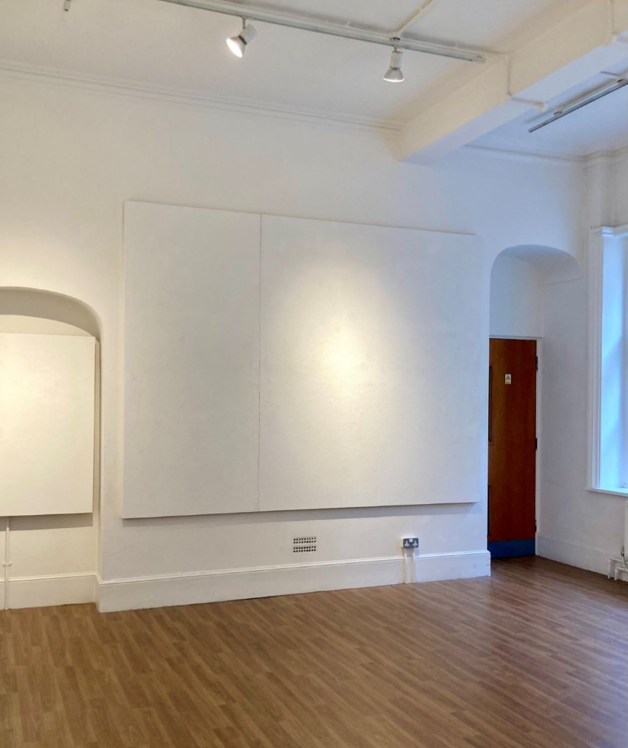
The space in the Old Town Hall Richmond
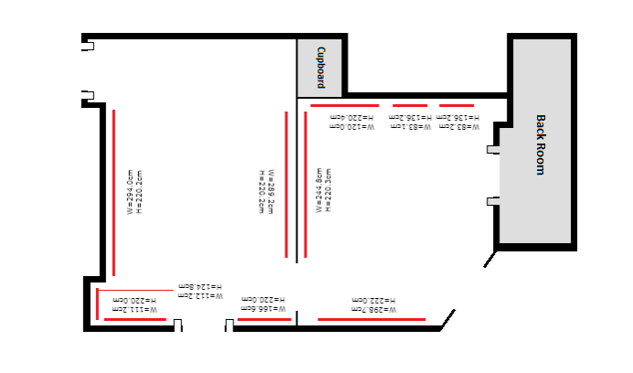
Floorplan of the space in the Old Town Hall Richmond
_________________________________________________________________________

Workshop at Orleans House Gallery
Open during the Gallery’s public opening hours, Tuesday – Sunday, 10am – 5pm
3-week placement in May 2027 with closures over the bank holidays.

Includes, at the artist(s) request: An artist sink, storage for specialist materials and equipment, tables, chairs

Accessibility: The space is located on the Ground floor of the courtyard at Orleans House Gallery, and an accessible toilet is also on the same floor. The space may on occasion need to be accessed (upon agreement with the artist) by Orleans House Gallery staff for equipment.

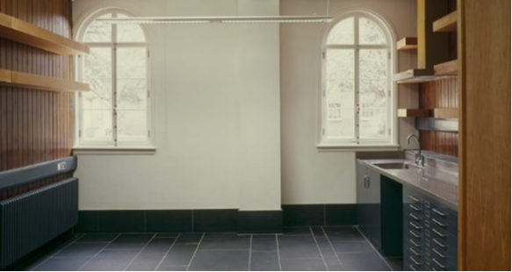
The Workshop at Orleans House Gallery
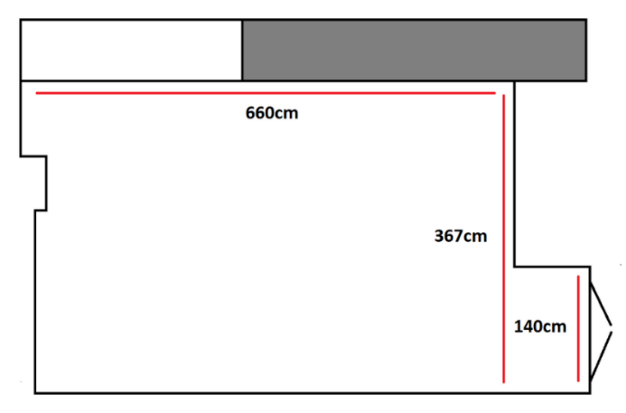
Floorplan of the Workshop at Orleans House Gallery
_________________________________________________________________________

Studio at Orleans House Gallery
Open during the Gallery’s public opening hours, Tuesday - Sunday, 10am - 5pm
11-month placement available between September 2026 - July 2027

Includes, at the artist(s) request: An artist sink, storage for specialist materials and equipment, tables, chairs

Accessibility: The space is located on the Ground floor of the courtyard at Orleans House Gallery, and an accessible toilet is also on the same floor.

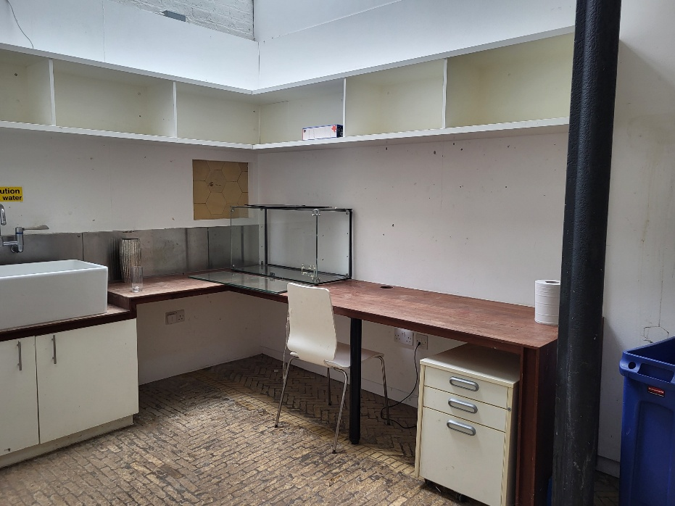
The Studio at Orleans House Gallery

_________________________________________________________________________

Coach House at Orleans House Gallery
Available Thursdays, 10am - 5pm
3 to 7-month placement available weekly on Thursdays, between September 2026 - July 2027

A large space that can accommodate up to 60 people

Includes, at the artist(s) request: audio-visual capabilities, large floorspace, tables and chairs, an artist sink, black out curtains/blinds, AV connection to large screen/projector
Integral sound system.

The room does not have a sprung floor but artists can provide one if necessary for their practice.

Accessibility: The space is located on the Ground floor of the courtyard at Orleans House Gallery, and an accessible toilet is also on the same floor.

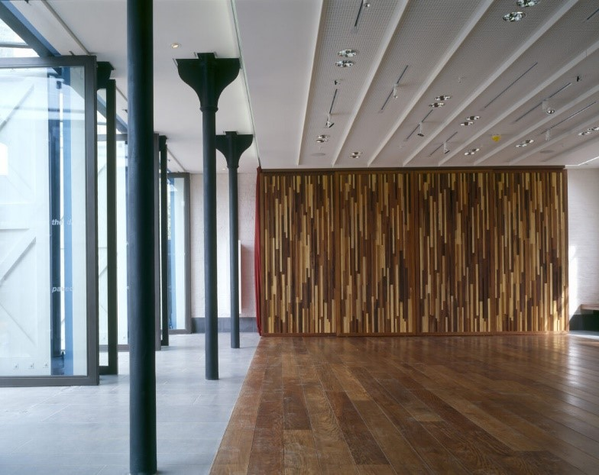
The Coach House at Orleans House Gallery, inside

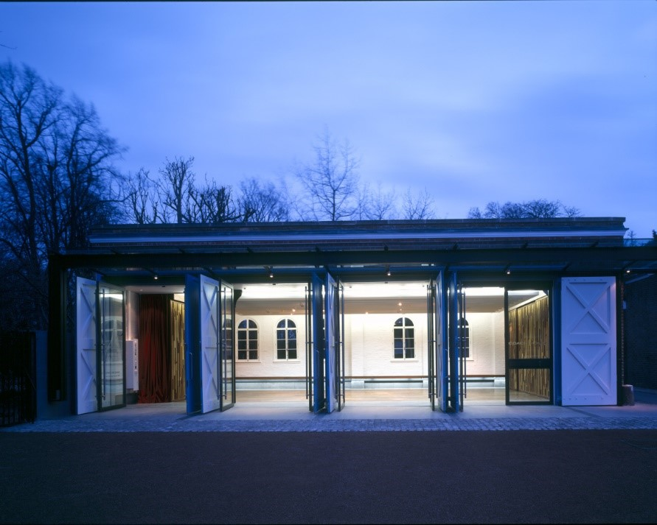
The Coach House at Orleans House Gallery, outside

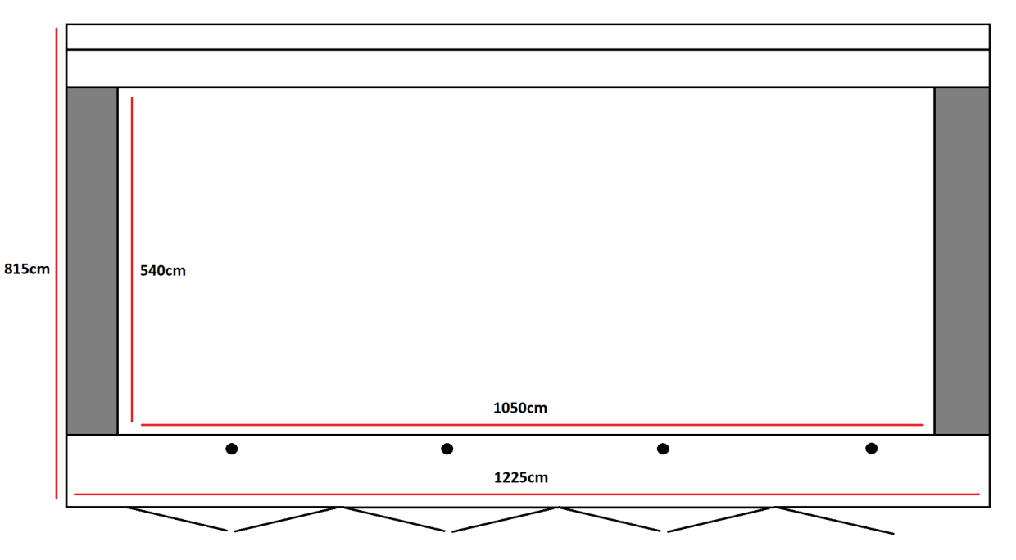
Floorplan of the Coach House at Orleans House Gallery

_________________________________________________________________________

Training Room at Orleans House Gallery
One-week placement available in early 2027
3-6-month placements available on weekends (excluding a few dates) between September 2026 -July 2027
A space that can easily accommodate up to 20 people.

Includes: Tables, chairs, and audio-visual facilities to accommodate high quality hybrid meetings and presentations.
This space does not have access to an artist’s sink.

Accessibility: The space is located on the 2nd floor at Orleans House Gallery, it is accessible by a lift and an accessible toilet is also on the 2nd floor nearby. There is also access to a small kitchen on this floor.

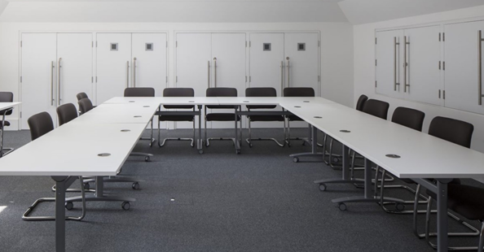
The Training Room at Orleans House Gallery
_________________________________________________________________________

Grounds of Orleans House Gallery
Open during the Gallery’s public opening hours, Tuesday – Sunday, 10am – 5pm
1 to 6-month placements available between September 2026 - July 2027

Woodland and front lawn suitable for outdoor practices.
This space does not have access to an artist’s sink.

Accessibility: The grounds and woodland cover uneven terrain. Some pathways along the grounds are paved. Paths in the woodland are not paved and can become muddy in rain.

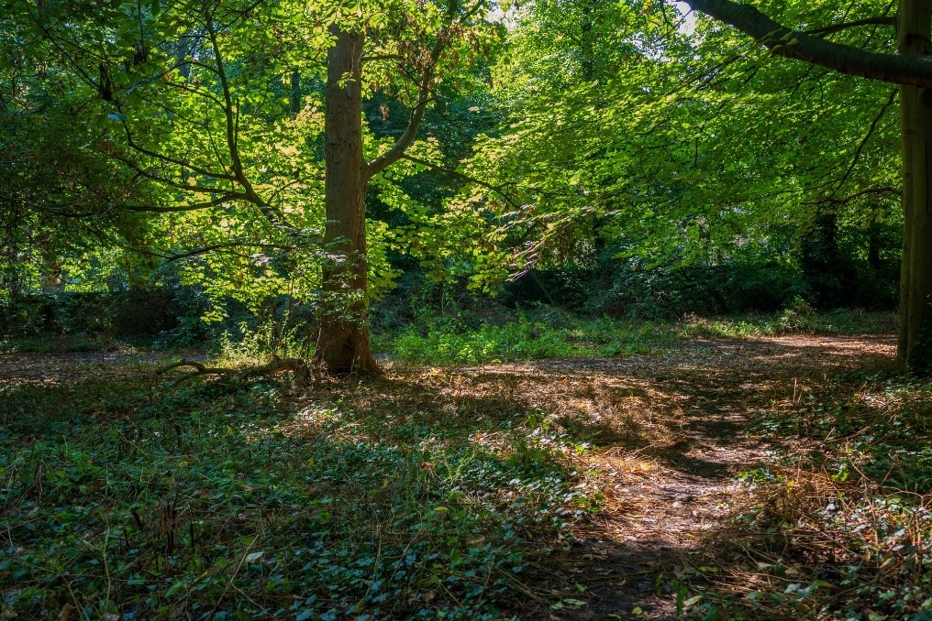
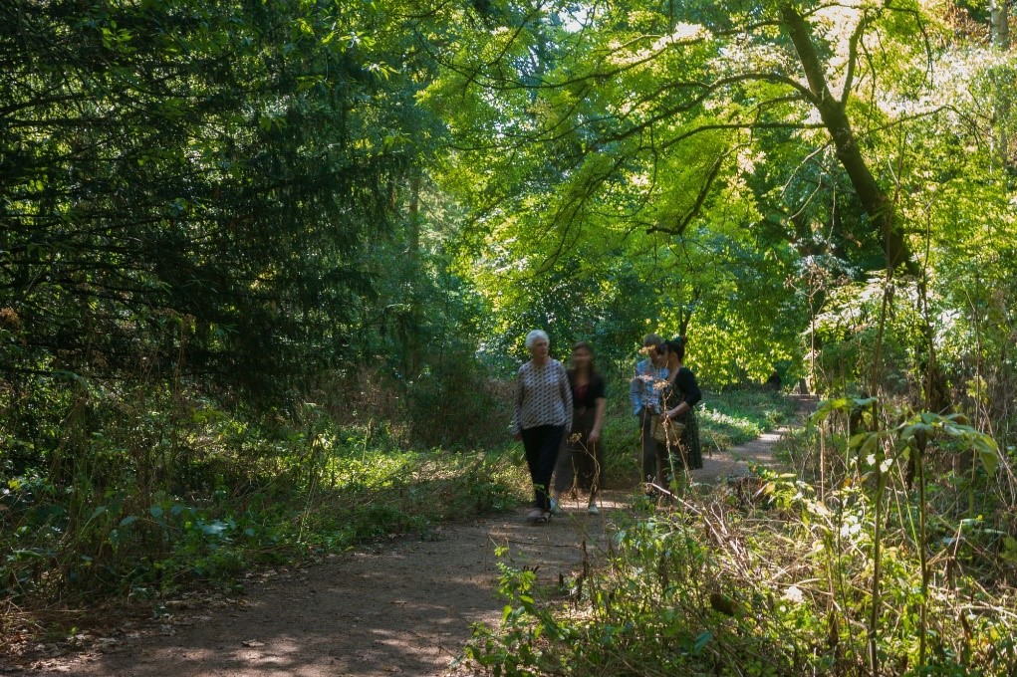
The Orleans House Gallery woodland, photographed by Eden Spence

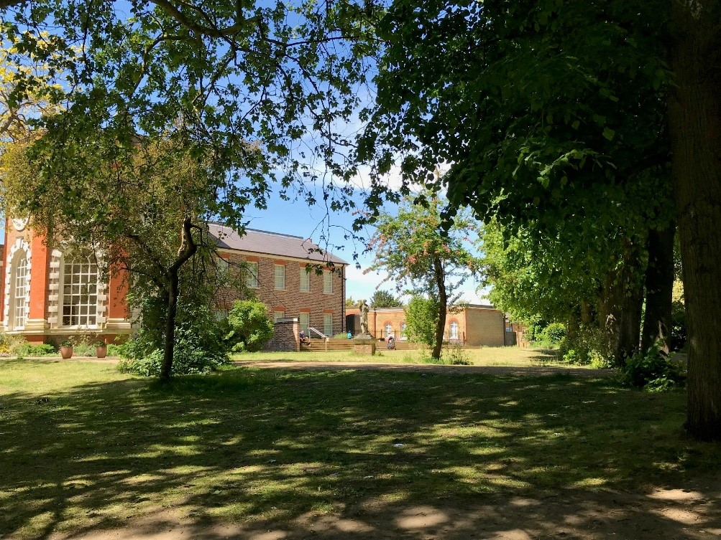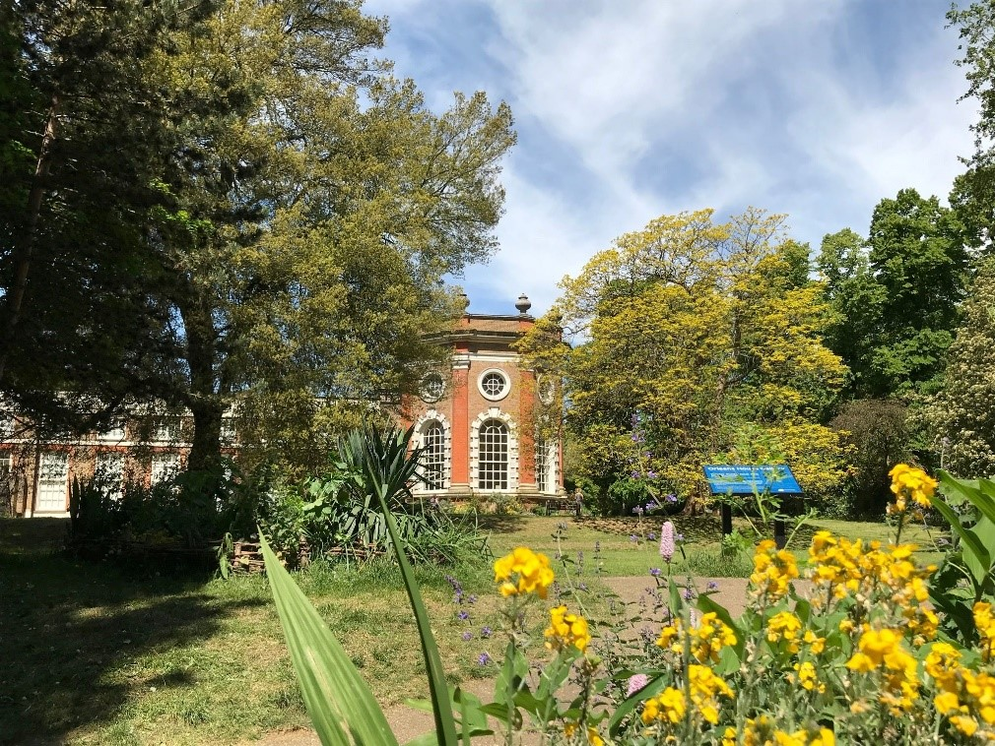
Orleans House Gallery grounds
_________________________________________________________________________

OSO Arts Centre, Barnes
12-week placement available, morning or afternoon (half day only), September 2026 - November 2026 (exact dates TBC)

Includes, at the artist(s) request: trestle tables, chairs
This space does not have access to an artist’s sink.

Accessibility: There is a ramp that leads to the automatic entrance doors at the OSO and the interior premises (including this space) are on one level, with access to accessible toilet facilities.

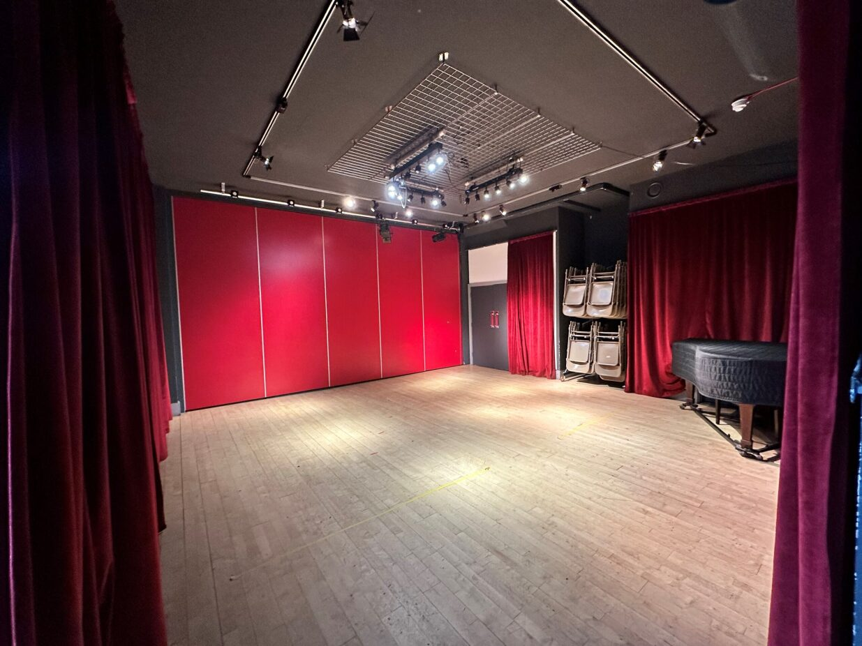
Space at OSO Arts Centre, Barnes
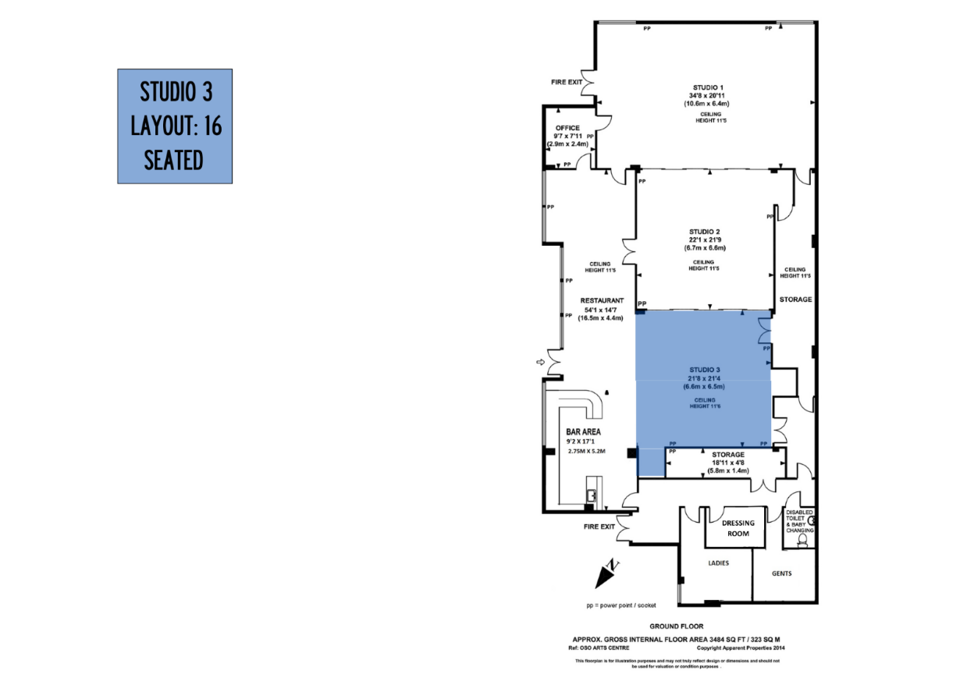
Floorplan of the space at OSO Arts Centre, Barnes

